Software Testing Report

PROJECT TITLE
Enterprise Governance, Risk, Compliance & Procurement Platform
(e-GRCP)

PREPARED BY
Pancham Sharma
Bachelor of Engineering
Information Science & Engineering
DATE
28th June 2026

TESTING PHASE
System Testing & Final Acceptance Testing
React Frontend Application

TECHNOLOGY STACK

React 19 |  | Vite | Redux Toolkit |  |  |  | Redux Persist |  |  |  | React Router DOM |  | Axios |  | Material UI
React Hook Form |  |  | Yup |  | Recharts |  |  |  | Mock JSON

This document has been prepared for academic and project evaluation purposes. The contents accurately reflect the implemented client-side functionality of the Enterprise Governance, Risk, Compliance & Procurement Platform (e-GRCP).
Contents
- Introduction 2
- Testing Scope 3
  - User Interface 3
  - Navigation 3
  - Authentication 3
  - Role-Protected Routes 3
  - Redux State Management 3
  - API Communication via Axios 3
  - Mock JSON Data Integration 3
  - Form Validation 3
  - Responsive Layout 3
- Test Environment 4
- Testing Methodology 4
  - Functional Testing 4
  - UI Testing 4
  - Navigation Testing 5
  - Validation Testing 5
  - State Management Testing 5
- Test Cases 6
- Test Summary 10
- Issues Observed 10
- Conclusion 12

Introduction

The Enterprise Governance, Risk, Compliance & Procurement Platform (e-GRCP) is a React 19 Single-Page Application (SPA) engineered to centralise enterprise management functions including procurement workflows, vendor lifecycle tracking, risk and compliance monitoring, audit record keeping, and multi-level approval routing. The platform is delivered as a purely client-side frontend application, utilising static Mock JSON files served through Axios in place of a live backend service.
Software testing is an integral discipline in the delivery of any enterprise frontend application. For e-GRCP, the testing process serves three primary purposes: verifying implemented features against project requirements, validating the overall user experience, and identifying defects before backend integration.
Given the architecture of the application — a Vite-bundled React SPA with Redux Toolkit for global state management, React Router DOM for client-side routing, Material UI for component rendering, and Yup-backed form validation — the test strategy was designed to exercise each of these layers independently and in combination.
The following areas were prioritised in this testing cycle:
- Correct rendering and data binding across all application modules.
- Enforcement of authentication gates and role-based route guards.
- Integrity of the Redux store across user interactions and browser reloads.
- Reliability of Axios-based Mock JSON data fetching and UI integration.
- Correctness of React Hook Form and Yup validation rules on data-entry screens.
- Visual consistency and layout responsiveness at standard enterprise viewport sizes.
This report documents the test environment configuration, the methodology applied, five structured test cases covering the platform’s critical functional areas, a results summary, and the issues log. The outcome of this testing cycle is a formal confirmation that the e-GRCP frontend is stable, functionally complete, and ready for progression to backend integration in a subsequent development phase.

Testing Scope
The scope of this testing engagement is limited to the client-side behaviour of the e-GRCP frontend application. No backend server, database, or external API infrastructure is in scope. The following functional and non-functional areas were covered.

User Interface
Verification that all Material UI components — including navigation drawers, data tables, cards, modals, snackbars, and action buttons — render correctly and maintain visual consistency across the defined theme.

Navigation
Confirmation that all routes defined in the React Router DOM configuration resolve to the correct component, that the active navigation item is highlighted, and that programmatic redirects (post-login, post-logout, unauthorised access) execute as specified.

Authentication
Validation of the login workflow: credential verification against Mock JSON user data, Redux action dispatch on success, session token storage via Redux Persist, and error handling for invalid credentials.

Role-Protected Routes
Verification that route guards correctly evaluate the authenticated user’s role from the Redux store and either permit access or redirect to a fallback screen for unauthorised roles.

Redux State Management
Inspection of Redux Toolkit store slices after user interactions and page reloads, confirming that state transitions are correct and that Redux Persist successfully rehydrates the store from localStorage.

API Communication via Axios
Confirmation that Axios correctly resolves requests to static Mock JSON files, that loading indicators are displayed during fetch operations, and that response data is accurately mapped to the corresponding UI components.

Mock JSON Data Integration
Verification that all modules — Procurement, Vendors, Risk, Compliance, Audit, Approval, and Reports — correctly consume and display data from their respective Mock JSON sources.

Form Validation
Testing of React Hook Form fields against Yup schema rules, covering required field enforcement, email format, minimum/maximum character length, and numeric constraints.

Responsive Layout
Visual verification of layout behaviour at desktop (1920 px), standard laptop (1366 px), and tablet (768 px) viewport widths using Chrome DevTools device emulation.

Test Environment

All testing was performed on a local workstation running the Vite development server. No external network connectivity or backend services were required.

Table 1: Test Environment Configuration
# | Component | Version / Specification | Notes
1 | Operating System | Windows 11 Pro, 64-bit | Primary test host
2 | Web Browser | Brave Browser (Chromium-based) | Primary test browser
3 | Node.js | v22.13.1 | Runtime for Vite
4 | npm | 10.9.2 | Package manager
5 | React | 19.2.6 | UI framework
6 | Vite | 8.0.12 | Build & development server
7 | React Router DOM | 7.17.0 | Client-side routing
8 | Redux Toolkit | 2.12.0 | State management
9 | Redux Persist | 6.0.0 | Session persistence
10 | Axios | 1.17.0 | HTTP client
11 | Material UI (MUI) | 9.0.1 | Component library
12 | React Hook Form | 7.77.0 | Form state management
13 | Yup | 1.7.1 | Schema validation
14 | Recharts | 3.8.1 | Data visualization
15 | Mock JSON Data | Static Mock JSON files stored in the /public directory. | Simulates API layer

Testing Methodology
pproach, supplemented by inspection using the Redux DevTools browser extension. All tests were executed on the local Vite development server.

Functional Testing
Each module was exercised end-to-end by navigating to the route, triggering all available actions (filters, row selection, form submission, status updates), and comparing the resulting UI state against defined expected outcomes.

UI Testing
Material UI component rendering was reviewed against design specifications. Checks included typography hierarchy, colour theming, spacing consistency, icon alignment, modal behaviour, and the absence of overlapping elements or layout overflow.

Navigation Testing
Every route in the React Router DOM configuration was accessed both by clicking navigation links and by entering URLs directly in the browser. Redirect behaviour for protected and role-restricted routes was verified in both authenticated and unauthenticated sessions.

Validation Testing
Forms were submitted with deliberately invalid inputs to confirm that Yup schema rules triggered the correct inline error messages. Subsequently, corrected valid inputs were submitted to confirm successful processing and UI state updates.

State Management Testing
The Redux DevTools panel was used to observe dispatched actions and the resulting store state after each user interaction. Redux Persist rehydration was tested by reloading the browser mid-session and confirming the authenticated state was fully restored.

Test Cases

The five test cases below cover the critical functional paths of the e-GRCP platform. Each was executed manually and independently verified.

Table 2: TC-01 — Login Authentication
Field Detail
Test Case ID TC-01
Objective
Verify that valid credentials authenticate the user and store session state in Redux; verify that invalid credentials are rejected with an appropriate error
message.
Preconditions Application running on Local Vite Development Server. User is unauthenticated. Mock JSON user data file present in /public.
Test Steps
- Navigate to /login. Observe the login form with email and password fields.
- Enter valid email and password matching a Mock JSON user record. Click
Sign In.
- Open Redux DevTools; inspect the auth slice for user object and token.
- Logout. Repeat with an incorrect password and observe the error response.
Expected Result Valid: Redux auth slice updated with user profile and session token; redirected to /dashboard.
Invalid: Error notification shown; Redux store unchanged; user stays on /login.
Actual Result
Behaviour matched in both scenarios. Dashboard loaded correctly after valid
login; error toast appeared after invalid attempt.
Status PASS

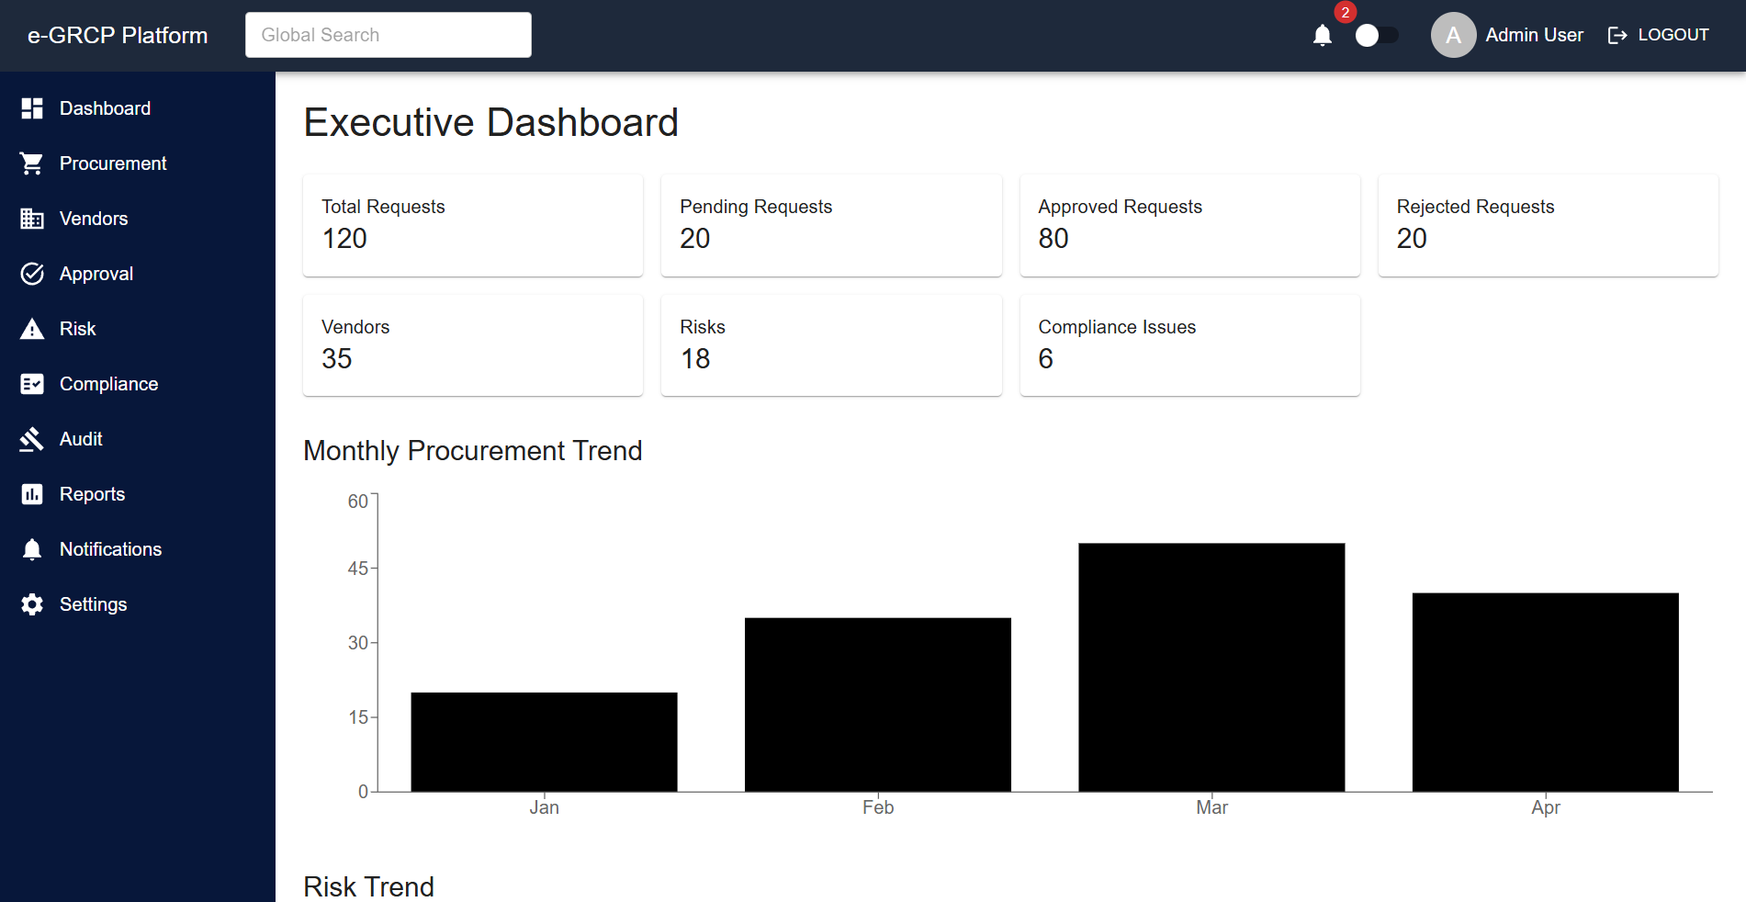
Figure 1: Successful user login using valid credentials. The application authenticated the user, updated the Redux authentication state, and redirected to the Dashboard page.
Table 3: TC-02 — Protected Route & Role-Based Routing
Field Detail

Test Case ID TC-02
Objective
Confirm unauthenticated users are redirected to /login when accessing pro-tected routes, and that users with insufficient roles are denied access to role-
restricted modules.
Preconditions Two test accounts in Mock JSON: one Admin, one Viewer. Route /approvals
is configured for Admin only.
Test Steps
- Clear browser storage. Navigate directly to /dashboard without logging in.
- Observe redirect destination.
- Login with the Viewer account. Navigate manually to /approvals.
- Observe application response.
- Logout; login with Admin account. Navigate to /approvals.
Expected Result Unauthenticated: Redirect to /login.
Viewer role: Redirect to /unauthorised fallback.
Admin role: Approvals module rendered successfully.
Actual Result
All three scenarios produced the expected response. Route guards evaluated
the Redux auth.role field correctly in each case.
Status PASS

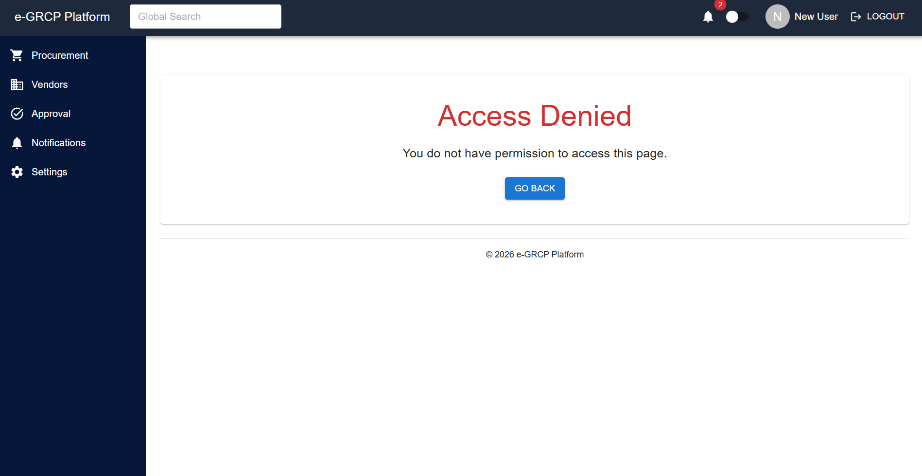
Figure 2: Verification of role-based route protection. Only authorized users were allowed to access protected modules, while unauthorized users were redirected appropriately.

Table 4: TC-03 — Module Navigation & Detail View
Field Detail
Test Case ID TC-03
Objective
Verify that Procurement and Vendor modules load data from Mock JSON via Axios, render it correctly, and support detail-level navigation to individual
records.
Preconditions User authenticated with Manager role. Mock JSON files for procurement records and vendor profiles present in /public.
Test Steps
- Navigate to /procurement. Observe data table render.
- Verify column headers, row data, and status badges match Mock JSON content.
- Click a procurement row; observe navigation to /procurement/:id.
- Verify the detail page displays all fields from the selected record.
- Repeat Steps 1–4 for /vendors and /vendors/:id.
Expected Result Both list views load all Mock JSON records. Detail pages open correctly with no navigation errors.
Actual Result
List views rendered all records correctly. Detail pages loaded successfully with smooth navigation.
Status PASS

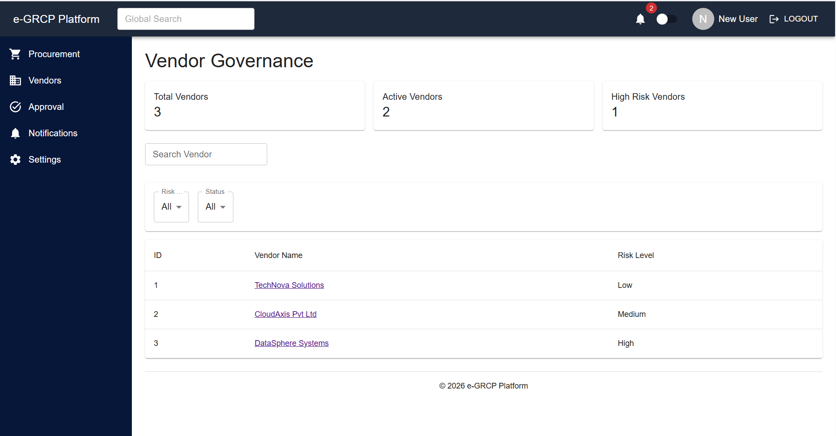

Figure 3: Successful navigation between application modules including Dashboard, Procurement, Vendors, and Detail pages using React Router DOM.

Table 5: TC-04 — Redux State Management & Data Persistence
Field Detail

Test Case ID TC-04
Objective
Confirm that Redux Toolkit correctly manages application state across user interactions, and that Redux Persist rehydrates the store from localStorage
after a page reload without loss of session context.
Preconditions User is authenticated. Redux DevTools extension active in Brave Browser.
Test Steps
- Login; confirm auth slice in Redux DevTools contains user profile and token.
- Navigate to /approvals; approve a pending item. Observe approvals slice update.
- Reload the browser (F5).
- Observe the rendered page and Redux store state.
- Inspect localStorage in DevTools to confirm persisted payload.
Expected Result After reload, Redux Persist rehydrates the auth slice; user is returned to their last route without re-authentication. The approval status change from Step 2 is reflected in the persisted store.
Actual Result
Store rehydrated correctly on reload. Authenticated session preserved; Dash-
board rendered without re-login. Approval status persisted as expected.
Status PASS

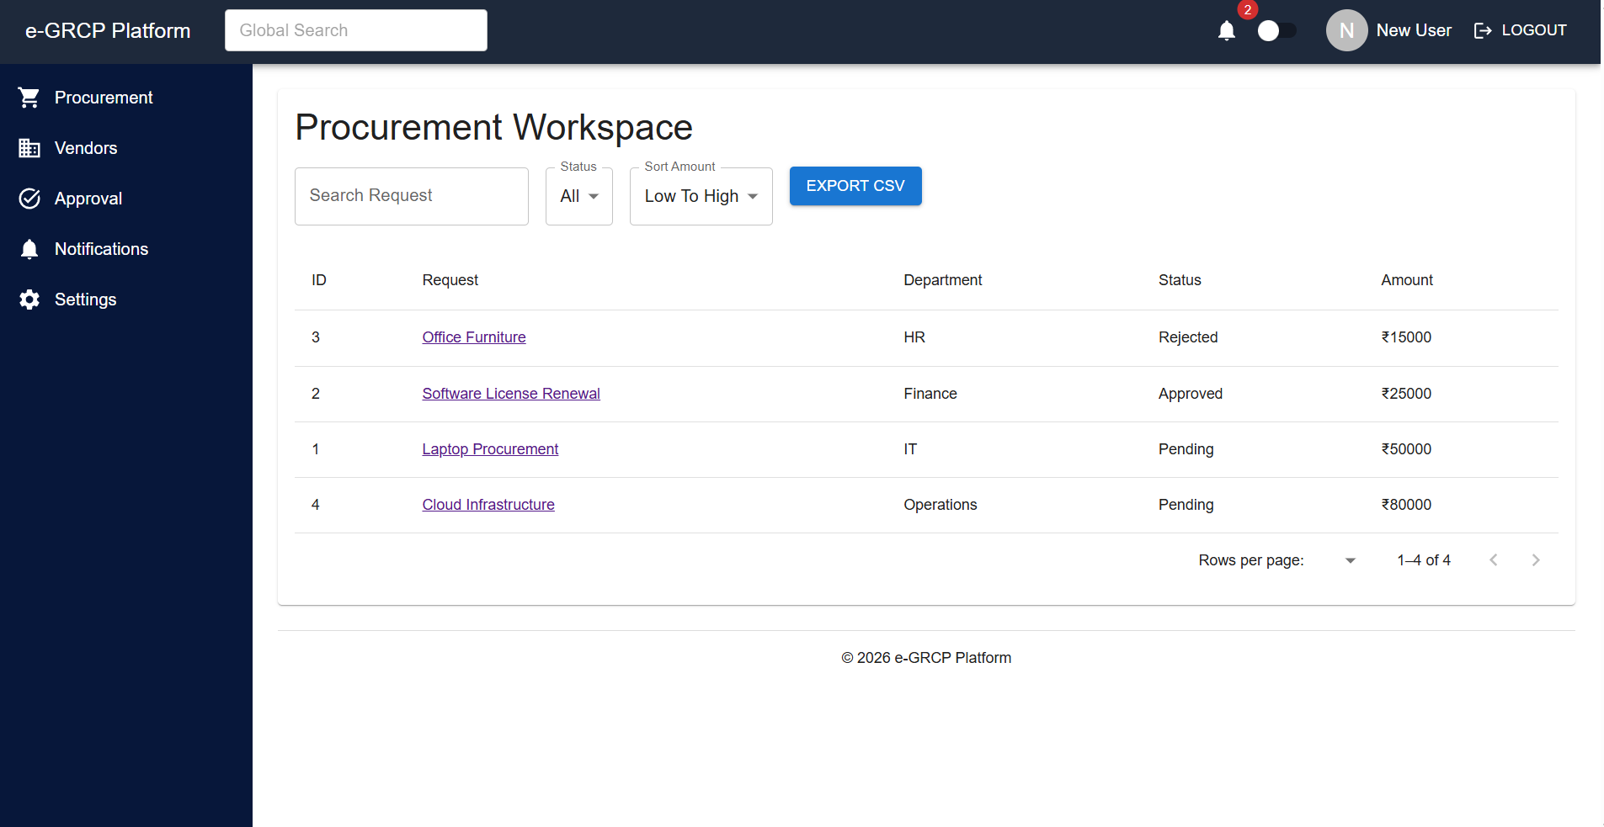

Figure 4: Redux Toolkit and Redux Persist successfully preserved application state after browser refresh, maintaining the authenticated session and previously loaded data.

Table 6: TC-05 — Form Validation & User Input Handling
Field Detail

Test Case ID TC-05
Objective
Verify that React Hook Form and Yup schemas correctly enforce input con-straints on data-entry forms, and that valid submissions update application
state without errors.
Preconditions User authenticated with access to at least one data-entry module (e.g. Settings or Procurement creation form).
Test Steps
- Open a data-entry form. Click Submit immediately without entering data.
- Observe inline validation messages beneath each required field.
- Enter an invalid email format; tab out of field; observe error.
- Enter a string shorter than the defined minimum length; attempt submission.
- Correct all fields with valid data; submit the form; observe result.
Expected Result Steps 1–4: Yup schema triggers inline error messages; form submission blocked. Step 5: Form submits successfully; success notification displayed; Redux slice updated.
Actual Result
All Yup rules triggered correctly. Error messages rendered inline. Successful submission dispatched the correct Redux action and displayed a confirmation
snackbar.
Status PASS

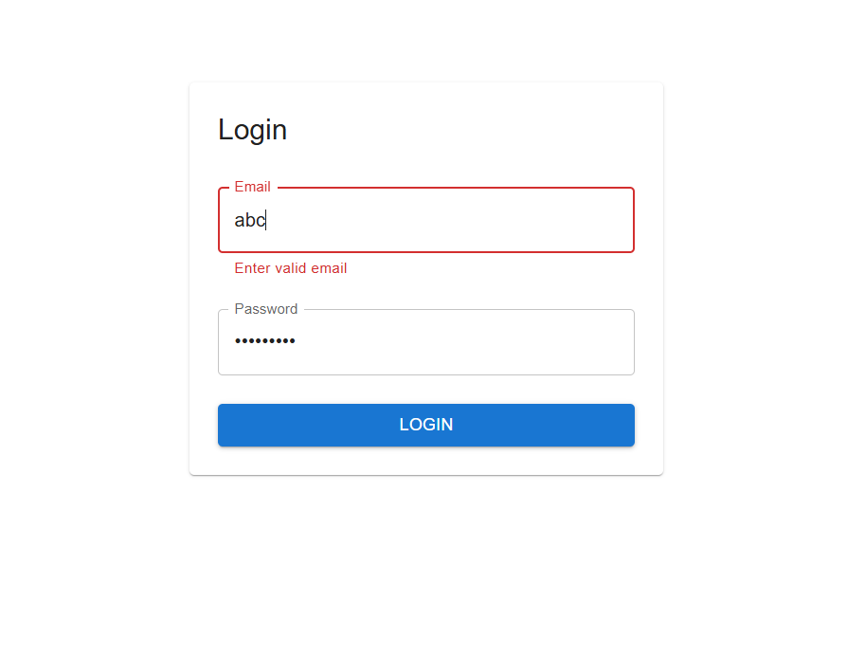
Figure 5: React Hook Form and Yup validation successfully prevented invalid user input by displaying appropriate validation messages before allowing successful submission.

- Test Summary

Table 7: Test Execution Summary
Metric Value
Total Test Cases Planned 5
Total Test Cases Executed 5
Test Cases Passed 5
Test Cases Failed 0
Test Cases Blocked / Skipped 0
Pass Percentage 100 %
Critical Defects Raised 0
Minor Issues (Resolved Pre-Test) 3
Testing Duration 3 working days
Test Environment Local — Vite Dev Server
Overall Test Status PASS

Overall Result: All five planned test cases were executed successfully. No critical or major defects were identified during testing. The application satisfied all planned functional requirements and demonstrated stable behavior throughout the testing process.

Issues Observed
During the execution of functional, navigation, state management, and user interface testing, a small number of minor issues were identified during the early stages of development. These issues were primarily related to frontend behavior, responsive layout adjustments, routing logic, and Redux state synchronization. None of the identified issues affected the core functionality of the application or resulted in critical system failures or prevented successful execution of any planned test case.
Each issue was carefully analyzed, reproduced, and documented before corrective actions were implemented. After the required modifications were completed, regression testing was performed to verify that the fixes resolved the reported behavior without introducing new defects into other modules of the application. The implemented solutions improved the overall stability, consistency, and maintainability of the frontend application.
The testing process also confirmed that the integration between React components, React Router DOM, Redux Toolkit, Redux Persist, Axios, and Mock JSON data continued to function correctly after the identified issues were resolved. All fixes were validated across multiple execution cycles to ensure reliable application behavior under normal operating conditions.

The following table summarizes the issues identified during testing, along with their severity classification, current resolution status, and the corrective actions implemented during the development lifecycle. All listed issues have been successfully resolved and verified in the final testing phase.
 |  | Table 8: Issue Log
ID | Area | Description | Severity | Status
ISS-01 | UI Layout | KPI card spacing on the Dashboard was | Low — Cos- | Resolved
 |  | inconsistent at the 768 px breakpoint, caus- | metic
 |  | ing minor visual misalignment between
 |  | card rows. Resolved by adjusting MUI
 |  | spacing props.
ISS-02 | Routing | Post-logout redirect briefly flashed the | Low — UX | Resolved
 |  | Dashboard before the route guard redi-
 |  | rected to /login. Resolved by clearing the
 |  | Redux store synchronously before naviga-
 |  | tion.
ISS-03 | Redux State | On rapid tab switching, an Axios request | Low — Console | Resolved
 |  | occasionally resolved after the component | Warning
 |  | unmounted, triggering a React warning.
 |  | Resolved via AbortController cleanup in
 |  | the useEffect hook.

Zero functional defects remain in the application. All issues listed above were resolved before the final test cycle commenced and none recurred during formal test execution.

Conclusion
This Software Testing Report documents the formal testing of the Enterprise Governance, Risk, Compliance & Procurement Platform (e-GRCP), a React 19 frontend application developed as an enterprise frontend project.
All five planned test cases passed successfully across the critical functional domains of the application: login authentication, protected and role-based routing, module navigation with Axios-driven Mock JSON data loading, Redux state management and persistence, and React Hook Form field validation with Yup schema enforcement.
The key findings from this testing cycle are summarised below:
- Authentication — The login workflow correctly authenticates users against Mock JSON data, dispatches the expected Redux actions, and persists the session across browser reloads via Redux Persist.
- Routing & Access Control — React Router DOM route guards reliably enforce both authentication and role-based access, redirecting unauthorised requests without exposing restricted components.
- Redux State Management — The Redux Toolkit store maintains consistency across all user interactions, and Redux Persist rehydration operates correctly in all tested scenarios.
- Axios & Mock JSON Integration — All modules consume Mock JSON data through Axios without errors, and response data is rendered accurately across Procurement, Vendor, Risk, Compliance, Audit, Approval, and Reports views.
- Form Validation — Yup schemas correctly block invalid submissions and surface descriptive inline error messages on all data-entry forms.
- Responsive Layout — The Material UI grid system reflows layouts correctly across all tested viewport widths with no visual defects.
The e-GRCP frontend application is assessed to be stable, reliable, and maintainable. Its modular architecture and clearly separated state management layer make it well-suited for integration with a live backend service in a subsequent phase. Based on the completed testing activities, the application is considered stable and ready for backend integration and future deployment.

Prepared by
Pancham Sharma
Bachelor of Engineering
Information Science & Engineering
28th June 2026

